Tickets can be purchased for 1, 2, 3, 4, 5, 6, 7, 8, 9 or 10 days and for any start date during the Valid for Arrivals Period Starting: February 25, 2025. Arrival Period Ending: December 31, 2025, subject to availability. The end date of the Ticket shall be set forth in the “End Dates” chart below.
One or more parks may be closed due to refurbishing, capacity, low demand, weather, or special events on one or more dates that the tickets specifically permit admission for. Parking is not included.
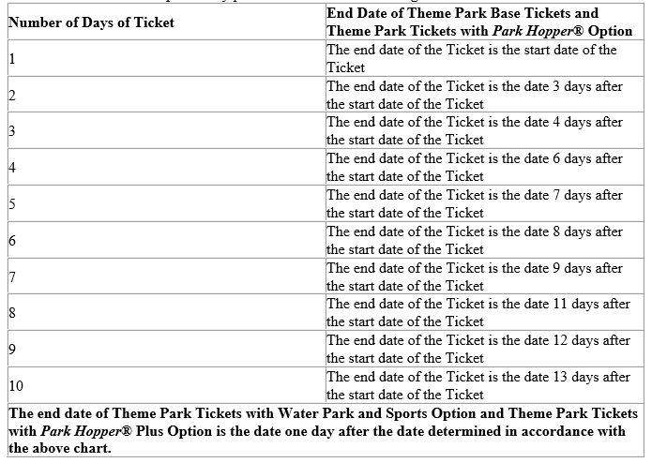
3-10 Day tickets are discounted at 20% off gate prices + tax, and 1-2 Day tickets are discounted at 10% off gate prices + tax.
It is important that your attendance dates are correct at time of purchase. Tickets are non-refundable. If your dates of attendance change after purchase, you will need to contact Disney World at 407-939-4357. Additional fees may apply.
Tickets can be purchased by all MWR eligible patrons and can be gifted.
For Walt Disney World Military Salute tickets, please refer to our Salute price sheet.

SUBASE MWR Tickets offers discounted Walt Disney World tickets! Please see back for details.
Tickets are date-based and variable priced. Please call, stop in, or email us for details. Price inquiries will require dates of attendance.
Ask us about Disney World’s Special Child Ticket offer if you’re visiting Disney World between May 27 and September 20, 2025.
We also offer 1-Day Disney World Water Park Tickets: $68.50 for ages 10 & up, $61.75 for children aged 3-9 years old. These tickets are blocked out from May 24-September 28, 2025. The 1-Day Water Park tickets with no blockout dates are $75.25 for ages 10 & up and $69.00 for children aged 3-9.
We also offer FL Resident and After Hours tickets!

SUBASE MWR Tickets is located in the MWR Library – Bldg. 164.
860-694-3723
ITTNewLondon.fct@navy.mil
Please call ahead before stopping in to ensure a ticket seller is available.

